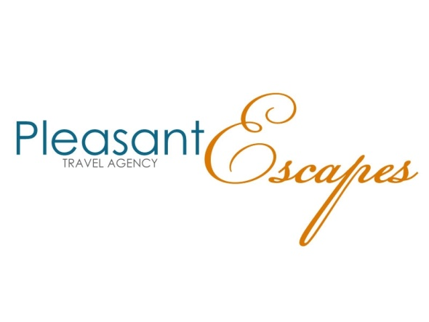
Kara Pleasant
Pleasant Escapes
107 Overton Road
Madison, Alabama 35758
256.542.9181
One Time Credit Card Payment Authorization Form

Sign and complete this form to authorize Pleasant Escapes/Palm Coast Travel or its suppliers to make a one time debit to your credit card listed below. Email completed form back to Admin@pleasantescapes.com

Please complete the information below:

I ____________________________ authorize Pleasant Escapes or its suppliers to charge my credit card
(Full name)

account indicated below for _____________ on or after ___________________. This payment is for
(Amount) (Date)

____________________________
(Brief description of the travel services that you are purchasing)

Billing Address ____________________________ Phone# ________________________
City, State, Zip ____________________________ Email ________________________

Account Type: Visa MasterCard AMEX Discover
Cardholder Name _________________________________________________
Account Number _____________________________________________
Expiration Date ____________
CVV2 (3 digit number on back of Visa/MC, 4 digits on front of AMEX) ______

SIGNATURE DATE

I authorize Pleasant Escapes/ Palm Coast Travel or its suppliers to charge the credit card indicated in this authorization form according to the terms outlined above. This payment authorization is for the goods/services described above, for the amount indicated above only, and is valid for one time use only. I certify that I am an authorized user of this credit card and that I will not dispute the payment with my credit card company; so long as the transaction corresponds to the terms indicated in this form. I agree that I will pay for this purchase in accordance with the issuing bank cardholder agreement.

Palm Coast Travel is an approved travel agency authorized to conduct business with all travel suppliers including, but not limited to airlines, car rental agencies, hotels, cruise lines, tour operators, and travel insurance companies. Your professional travel agent Pleasant Escapes/Kara Pleasant is contracted with Palm Coast Travel for the purchase of these various travel services, therefore, it is required that you comply with our credit card acceptance policies. You should complete this form if you are using your credit card to purchase travel services for yourself or other individuals known to you. Please fully complete and return this form to your travel agent (Kara Pleasant) using the instructions provided. The purpose of this Credit Card Authorization form is to comply with credit card acceptance rules with travel suppliers and to protect you the cardholder, Palm Coast Travel, and your travel agent (Kara Pleasant) from credit card fraud. If you have any questions or concerns regarding this form, please contact your travel Agent. This form must be completed and signed by the cardholder. Pleasant Escapes/Palm Coast Travel reserves the right to request additional information from the cardholder. If fraud is suspected, Pleasant Escapes/Palm Coast Travel reserves the right to deny this transaction.

